Lab: Unit Testing Methods
Submit your solutions here: https://judge.softuni.org/Contests/4680/Unit-Testing-Methods-Lab

Unit Test: Calculator
Look at the provided skeleton and examine the Calculate class that we are testing:
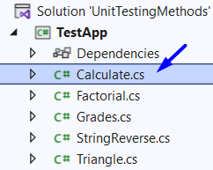
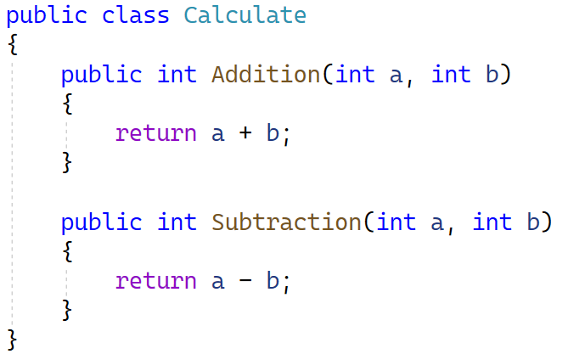
Then look at the unit tests for the above class:
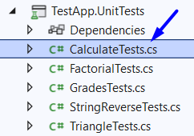
Look around the CalculateTests class to see how unit tests are written. This is how our unit tests look like:
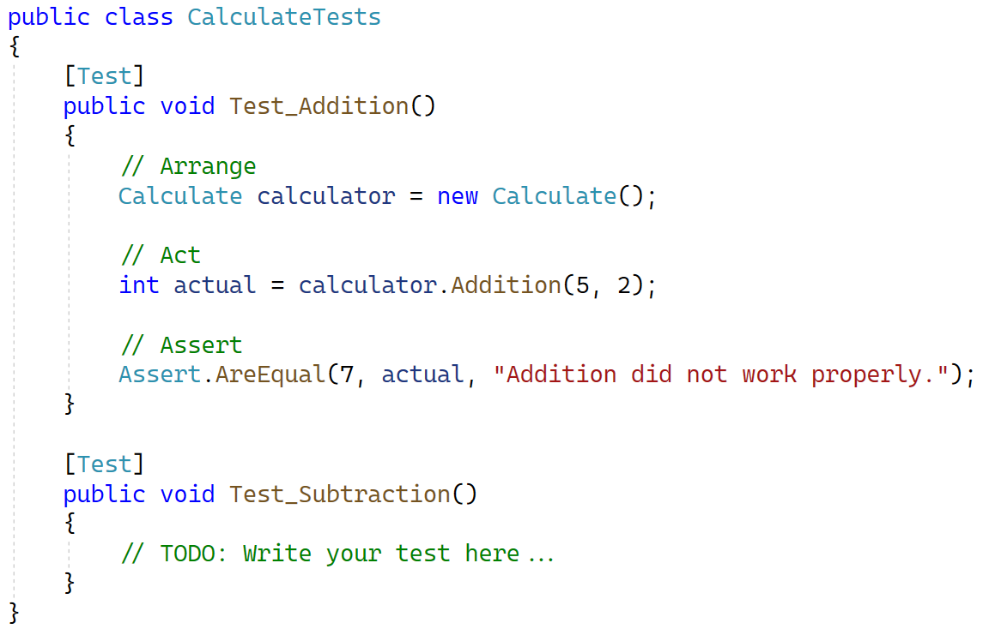
Here is how the Test_Addition() test works.
First, we create an instance of the class we are going to test. This is part of our "Arrange" section:
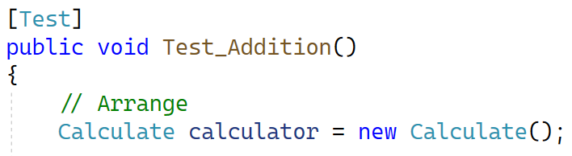
Next, as part of our "Act" section we call the Addition() method from our instance passing in the required arguments and storing the result in an integer.
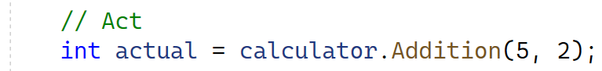
At the end for our "Assert" section we are going to call Assert.AreEqual() and pass in an expected value we want to see, the actual value that the method returned and a failure message in case the test does not pass.
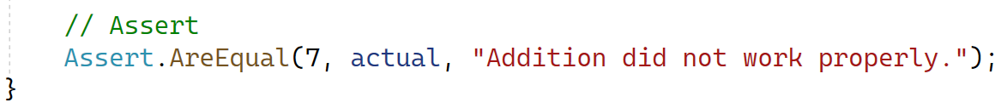
Now try to create your own unit test in the same class following the existing example to test the Subtraction() method from the same class.
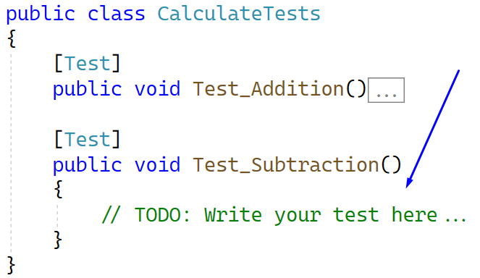

How to Run Tests
To run your tests, navigate from the navbar: [Test] [Test Explorer] or just press [Ctrl] + [E], [T]. From there your "Test Explorer" is going to open, press the two green triangles to "Run All Tests in View" ([Ctrl] + [R], [V]) or the single green triangle to run the selected test ([Ctrl] + [R], [T]).
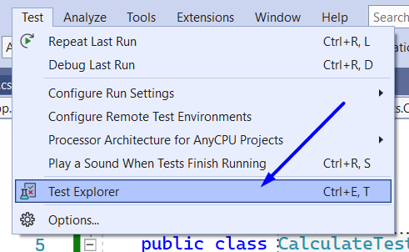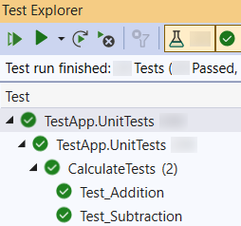
When you are ready this is how the tests should look like:
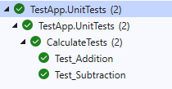

Unit Test: String Reversal
Next you will test a method which accepts a string and returns the string but reversed.
The method is found in the StringReverse.cs file:
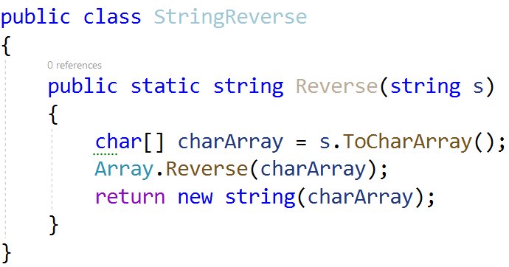
You are given again a test file StringReverseTests.cs which contains 3 tests. One of them has been finished partially:
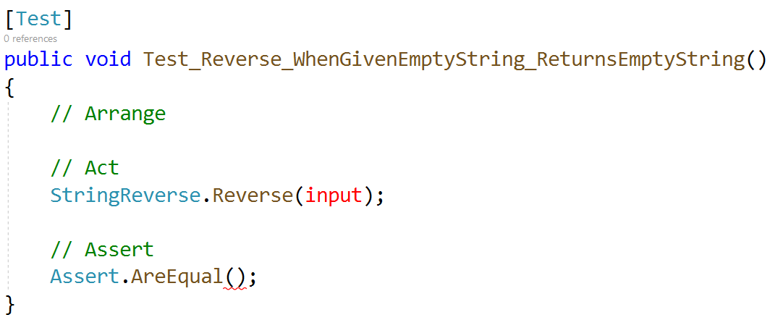
Finish the first test and using the names of the other two finish writing the unit tests:
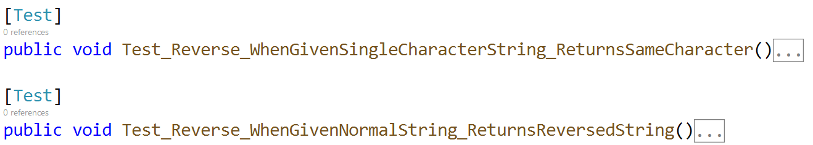
When you are ready this is how the tests should look like:
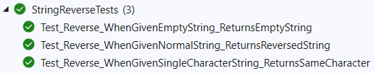

Unit Test: Triangle
Moving right along, a method that prints a pyramid of numbers with a given size like so:
Size 3 | Size 4
1  1 2  1 2 3  1 2  1 | 1  1 2  1 2 3  1 2 3 4  1 2 3  1 2  1
Found in the Triangle.cs file:
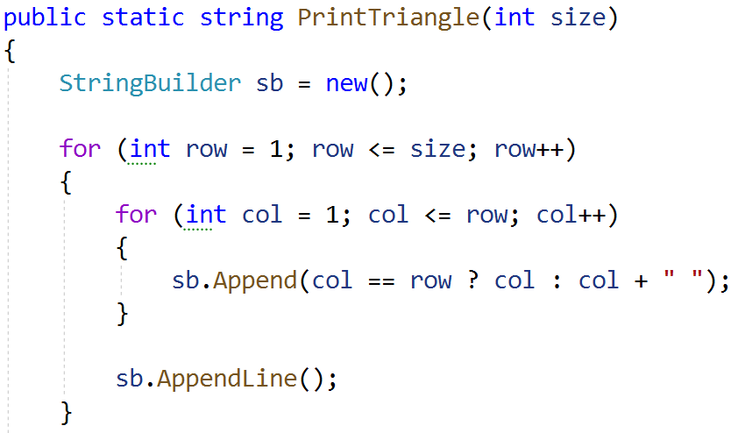
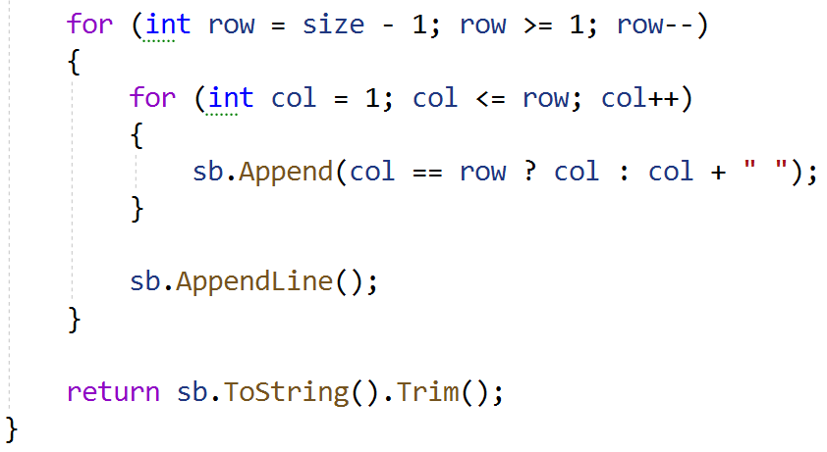
For the test file again, you are given the test names, based on them you should be able to write all the necessary tests:
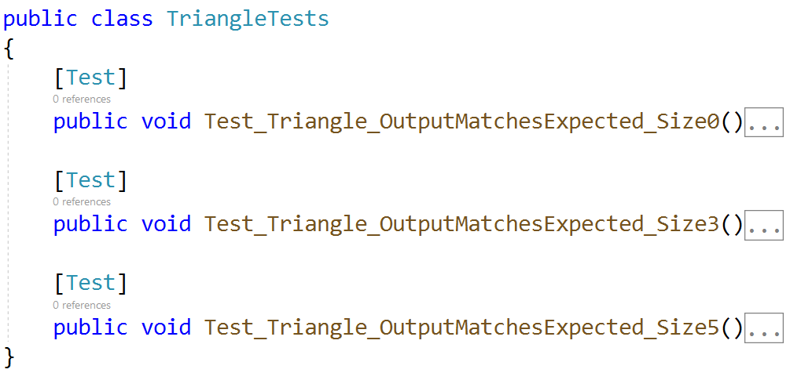

Hints
Use Environment.NewLine when formatting your expected string.
Make sure your tests pass:
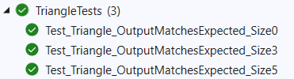

Unit Test: Factorial
You are given a method which calculates factorial of a given number in the Factorial.cs class:
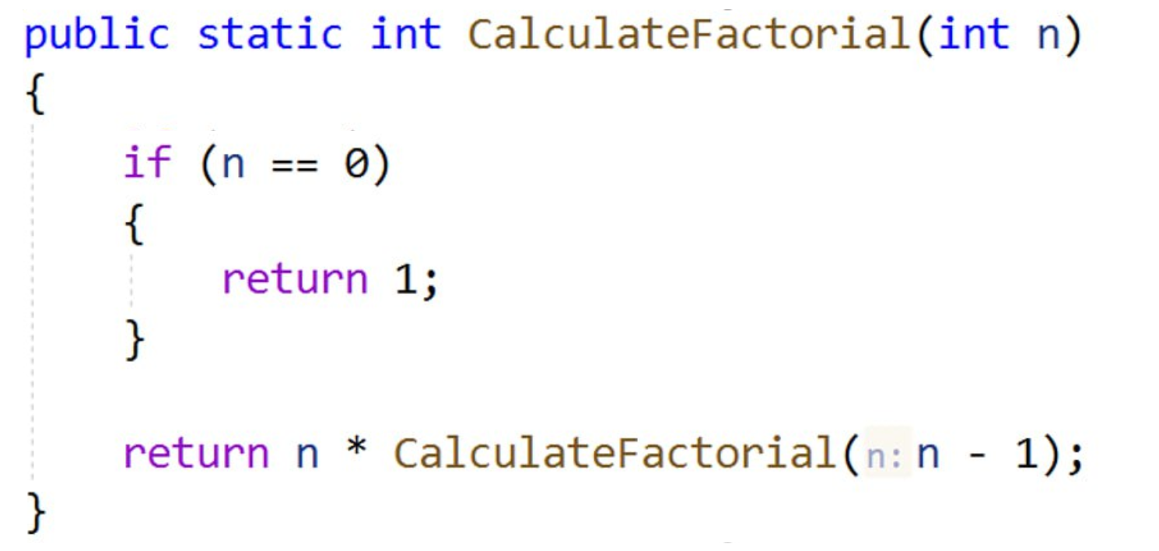
The drill is the same, implement the unit tests based on name:
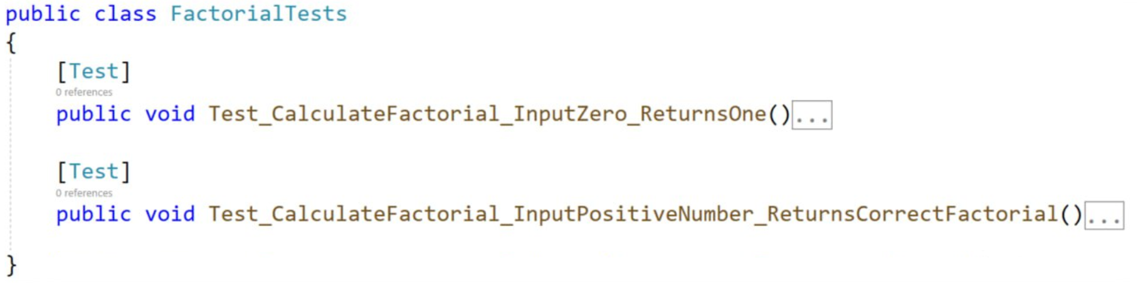
Make sure your tests pass:
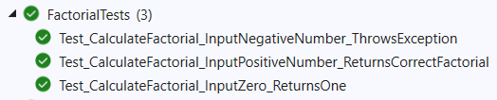

Unit Test: Grades
We have a method that receives a grade between 2.00 and 6.00 and prints the corresponding grade as a string.
- 2.00 … 2.99 ➡ "Fail"
- 3.00 … 3.49 ➡ "Average"
- 3.50 … 4.49 ➡ "Good"
- 4.50 … 5.49 ➡ "Very good"
- … 6.00 ➡ "Excellent"
- Other ➡ "Invalid!"
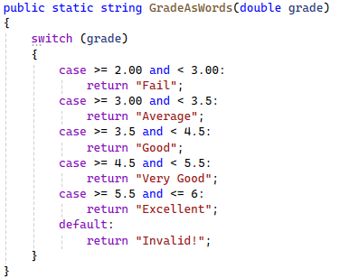
When writing the unit tests try to use multi data tests. Let's see how, by doing it on our calculator tests:
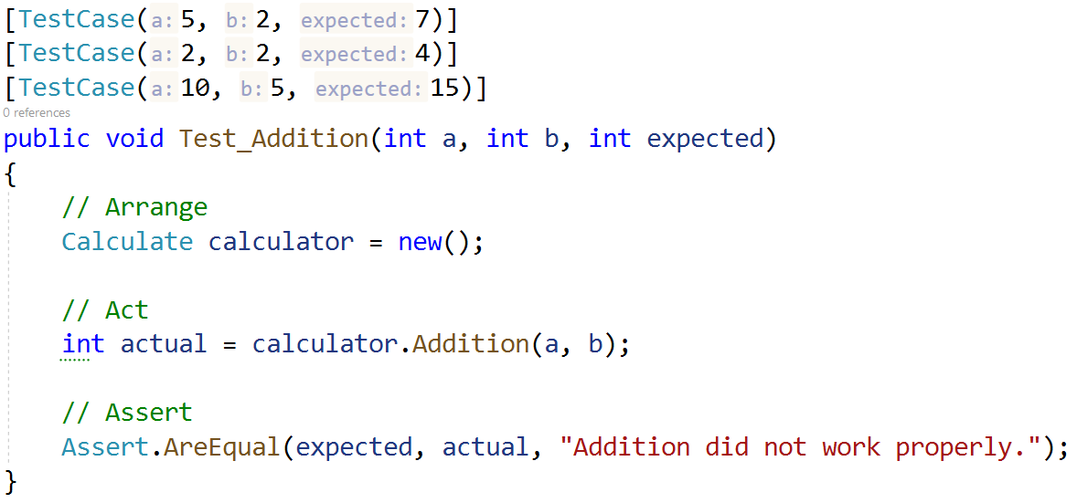
A test is just a method which means we can pass parameters on it. By doing this we can call the same test multiple times if the test needs to be executed for different test cases.
Having this knowledge, you are given only 2 tests for the GradeAsWords() method:
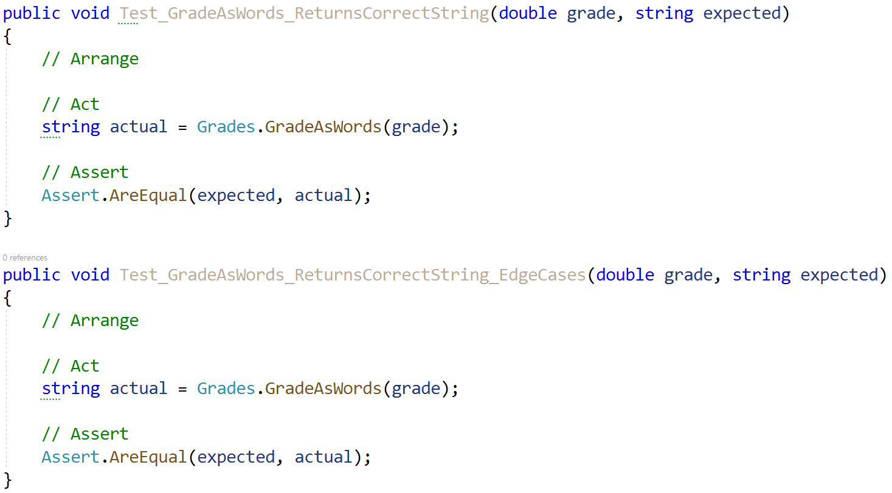
One test checks the normal functionality of the method, while the second deals with edge cases. Both tests accept the grade and expected string as arguments. Your task is using [TestCase()] write as much test cases as you see fit, to cover as much cases as possible.
We managed to get 18 test cases in total:
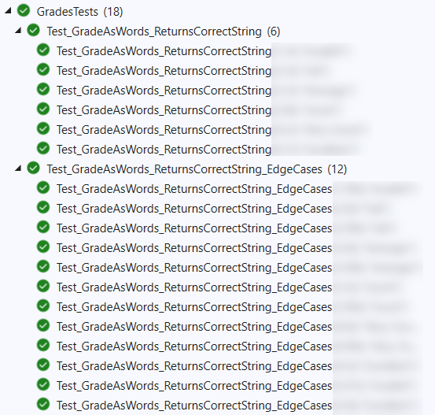
Finally make sure all your tests run:
